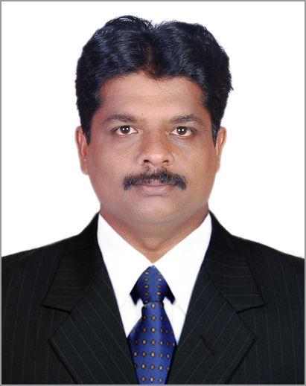CURRICULUM VITAE

VIJAYAN K.R

1. **365**

**Kariyil**

Mudur, Kundapura Udupi-Karnataka 576233

mob:9590205534

E-Mail: [vijayvaranad@gmail.com](mailto:vijayvaranad@gmail.com)

OBJECTIVE:

I am on look out for a professionally managed organization to take my career to the higher level .I have never die attitude& good discipline to handle responsibilities that entrusted with me. I request you to kindly give me an opportunity to groom my career in your organization.

EDUCATIONAL QUALIFICATIONS:

|  |  |  |  |
| --- | --- | --- | --- |
| QUALIFICATIONS | UNIVERSITY/BOARD | PERCENTAGE | PERIOD OF STUDY |
| M.A ENGLISH | ANNAMALAI UNIVERSITY,DDE | 52.7% | 2016-2018 |
| B.A BUSINESS ECONOMICS | ANNAMALAI UNIVERSITY,DDE | 48% | 2006-2009 |
| PRE-DEGREE | KERALA UNIVERSITY | 48% | 1994-1996 |
| S.S.LC | BOARD OF  EDUCATION | 51% | 1993-1994 |

EXPERIENCE OVERVIEW:

Presently working with Turtlemint Insurance Broking Pvt Ltd (FINTECH Blue Solutions Pvt Ltd) as

Associate City Head Since 13/06/2022 to till date.

. Passed BQP Exam (Broker Qualified Person)

. Branch/Team Handling Role

.Motor, Health, Life Vertical

. Got Confirmation on time

. Got salary increment 2 times

Worked with Manipal Cigna Health Insurance Co Ltd as a Retail Business Development Manager Since 06/10/2021 to 14/05/2022 (CTC 5 Lakh PA)

* Branch Handling Role, Managing 6 Frontline Managers

Worked for Royal Sundaram General Insurance Co Ltd since 15/04/2020 to till 01/10/2021 as a Territory Manager. (4.26 lakh CTC)

* Managing 50Advisors so far
* Got Confirmation on time
* Got Salary Increment on time
* Excellent Knowledge on Motor, Property, Health Products and its services

Worked for **Chola People Service Pvt Ltd** (Chola MS GIC LTD) since **07/06/2017** to **28/03/2020** as Process Lead - Bancasuurance (CTC 276000)

* Taking Care of the General Insurance Business of 100 Nationalized bank branches.
* Got confirmation on time
* Got Salary increment
* Good Knowledge on Motor ,Health, Property ,Fire and Burglary Insurances
* Excellent in Relationship Management

Worked for HDFC Standard Life Insurance Co Ltd Since 17-01-2014 to 27/02/2016 as Business Development Manager.

ACHIEVEMENTS

* Got confirmation on time
* Good and fast in team building
* Recruited 30 AdvisorsLicensed 20 Advisors Achieved Annual Target & Got Salary increment
* Worked for Institute of Language Management, Bangalore as a Sr. Faculty -Communicative English (Spoken English) since July 2009 to March 2012.
* ACHIEVEMENTS
* Excellent Appreciation from the clients and renewed all clients contract consecutively for 3 Years.
* Good presentation skills.
* Good communication skills Good English language expertise.

PERSONAL DETAILS:

Father’s Name : Ravindran

Religion : HINDU

Caste : OBC (II A)

Age : 46

DOB : 07/01/1978

Marital Status : Married

Hobbies : Drama Direction, Swimming, Karate, Gym workout

Language known : English, Malayalam &Kannada,

STRENGTHS : Positive Attitude, Friendly Behaviour, Self Confidence

Place: Udupi

Date (VIJAYAN)