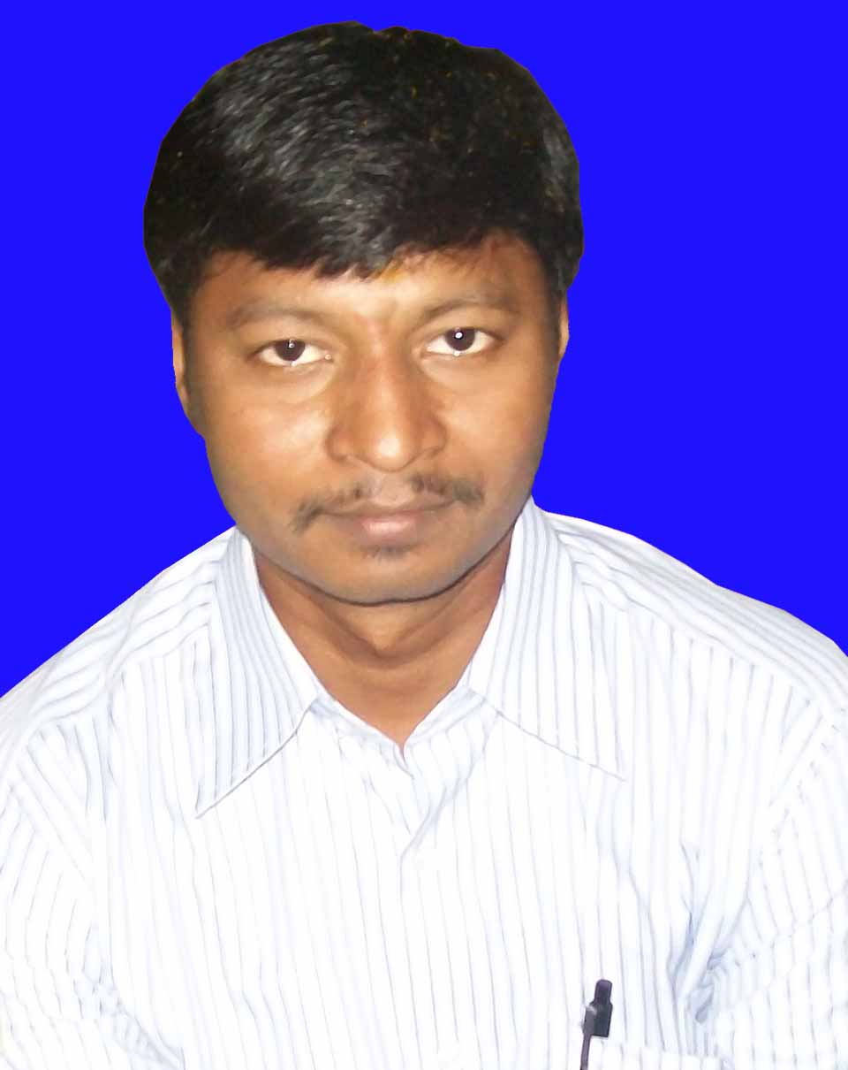

RAJESH KUMAR BEHERA

At / Po- BHAPUR BAZAR, BERHAMPUR, Pin – 760001
Mobile - 9437438190. Email rajesh.scsl@gmail.com

⬥ Area of Expertise – Area of Expertise – Area of Expertise 

To achieve a challenging position as an operation administrator where my skills and capabilities can contribute to company’s productivity.

Areas of Expertise

• Accounts | •Back Office Operations | • Customer Service
• Business and Commission MIS | • Dealing (odin/Nest Trade) | • I T software & hardware

Professional Experience and Significant Achievements

Job Title :- Asst. Manager (Operations) Date – 01.09.2014 TO till date

Company address / website: BONANZA PORTFOLIO LTD (BHUBANESWAR)
Website: www.bonanzaonline.com

- Trouble shooting and issue resolution for smooth Franchisee operations
- Technical Support for Software/Hardware related Problems
- Coordinating with Franchisees/Branches of Orissa and Chattishgarh
- Handling of Depository Participant operations like – DIS, DRF, Payin /Payout etc
- Handling accounts of client ledger and Stock
- Updating of back office software and ODIN

Job Title :- Back office cum Dealer Date – 08.12.2012 TO 31.08.2014

Company address / website: L K P Securities (BHUBANESWAR)
- Technical Support for Software/Hardware related Problems
- Handling accounts of client ledger and Stock
- Updation of back office software and ODIN, POWERTRADE, NOW software.
- Dealing in Stock Market ODIN/NEST TRADE

Job Title :- Back office cum Dealer Date – 05.03.2011 TO 31.03.2012

Company address / website: DESTIMONEY SECURITIES P LTD (BHUBANESWAR)
- Technical Support for Software/Hardware related Problems
- Handling accounts of client ledger and Stock
- Updation of back office software and ODIN, POWERTRADE, NOW software.
- Dealing in Stock Market ODIN/NEST TRADE

Job Title :- Back office Executive Date – 22.10.2008 TO 10.07.2010
Company address / website: BONANZA PORTFOLIO LTD (BHUBANESWAR)
Website: www.bonanzaonline.com

- Trouble shooting and issue resolution for smooth Franchisee operations
- Technical Support for Software/Hardware related Problems
- Coordinating with Franchisees/Branches of Orissa and Chattishgarh with HO
- Handling of Depository Participant operations like – DIS, DRF, Payin /Payout etc
- Handling accounts of client ledger and Stock

Job Title :- Back office Executive Date – 08.09.2006 TO 21.10.2008

Company address / website: STEEL CITY SECURITIES LTD
- Trading in NSE, BSE and F & O in ODIN and NEATCM software.
- Backup & file transfer of Trading to HO.
- Using File Transfer Protocol(FTP)
- Handling Delivery status of stock.

ACADEMIC RECORD

M.COM | Khallikote College, Berhampur (Orissa)
Degree (Accounting) | +3 Com. from Berhampur University, Berhampur
+2 Com. | +2 Com. from (Khallikote College Berhampur)
10TH | K C Town High School, Berhampur.

COMPUTER SKILLS:-
- DCA (MS Office, MS Word, MS Excel, MS Power Point)
- Knowledge of Hardware and Software Operations

Languages: English, Hindi, Oriya, Telugu, Bengoli.

Strengths: Team Player, Dedicated, & Prompt, Punctual.

Hobbies: Listening Music, Reading Books and interacting with the People

PERSONAL DETAILS:

Father's Name: - Late. Nageswar Behera
Nationality: - Indian
Religion: - Hindu
Date of Birth: - 05th May 1982
Marital status: - Un-Married

DECLARATION:

I do hereby declare that all the above statements furnished by me are true and correct to the best of my knowledge.

Date: -

Place:- Signature of the Candidate

