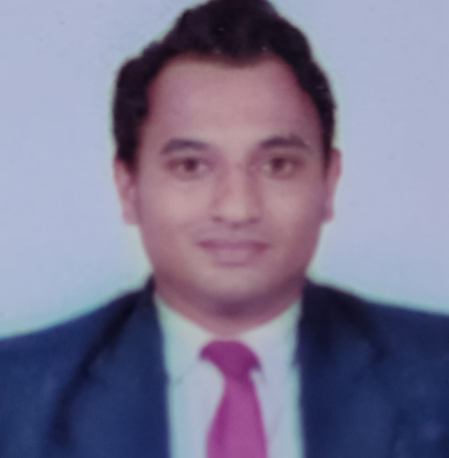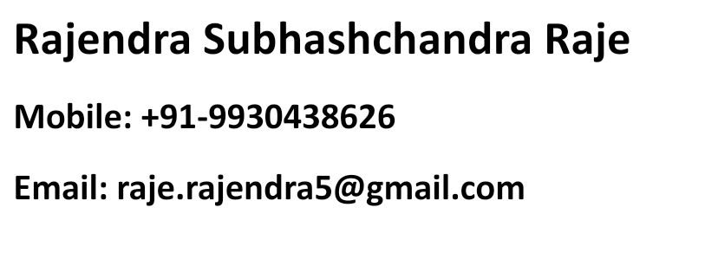

**PERSONAL VITAE**

**Date of Birth :** 6th July, 1987

**Address :** B-504 Bhoomi acres, waghbil behind hiranandani estate

G.B Road thane (w) 400615

**EDUCATIONAL CREDENTIALS**

B.Com from Vikas College, Mumbai in 2010 , MBA in Finance 2015 (Mumbai University)

Seeking assignments in Sales/ business development with a growth oriented organization of repute.

* An astute professional with above + 14 years of experience in Business Development, Marketing, Sales and Client Relationship Management.
* Experience in exploring and developing markets/ clients, thereby accelerating growth & achieving desired goals.
* Proficient at analyzing market trends to provide critical inputs for business development initiatives and formulation of selling and marketing strategies.
* Competent in collecting market information to fine tune marketing strategies.
* Excellent communication, interpersonal, liaison and problem solving skills with the ability to work in multi-cultural environments.

**CORE COMPETENCIES**

**Business Development**

* Identifying prospective clients, generating business from new accounts to achieve consistent profitability.
* Building and maintaining healthy business relations with major clientele, ensuring maximum customer satisfaction by achieving delivery & quality norms.
* Interacting with the customers to gather their feedback regarding the products’ utilities.

**Client Relationship Management:**

* Managing customer centric operations and ensuring customer satisfaction by achieving delivery timelines and service quality norms.
* Interfacing with clients for suggesting the most viable service / plan and cultivating relations with them for securing repeat business.

**Sales & Marketing**

* Managing sales & marketing operations thereby achieving increased sales/maximizing profit.
* Building brand focus, reviewing and interpreting market response to facilitate product growth.
* Implementing marketing plans for augmenting the business by enhancing brand visibility & recall.
* Executing business plans for maximizing profitability & revenue generation.
* Client Servicing

**Icici Prudential Insurance Area head October 2022 – Sept 2024**

* Handling RBL Bank Relationship .
* Channel partner management by acquiring mindshare .
* To drive insurance Business from assigned Relationship Channel Partner in an Area .
* To handle bank customer requirements with the best services and products range .
* Banca channel management . Tpp relationship management with servces offered .
* Monitor and drive monthly contest by conducting unit meeting weekly and monthly basis. Also design internal contest to motivate Channel partner .
* Managing team of Sales managers .
* Identify innovative methods of working with the relationship to enhance penetration of the database .
* Activation of Inactive Resources month on month to drive them for insurance .
* Conducting Training sessions for channel partners for driving them for Life insurance .

**Achievements:**

1 Rewarded as Top Areahead for making Highest SP Productive .

2 Recognised for highest Term plan Activation .

3 Awarded for Highest no of SM activation in Cluster

**Maxlife Insurance Ltd Areahead June 2021– October 2022**

* Handling Axisbank Relationship .
* Channel partner management by acquiring mindshare .
* Banca channel management .
* Monitor and drive monthly contest by conducting unit meeting weekly and monthly basis. Also design internal contest to motivate Channel partner .
* Managing team of Sales managers .
* Activation of Inactive Resources month on month to drive them for insurance .
* understand the client’s need & offer the best services.
* Mentoring & motivating team towards attainment of assigned targets.
* Lead , inspire and encourage the team to achieve maximum revenue .

**Achievements:**

1 Rewarded as Top Areahead PAN India for making Highest SP Productive .

2 Recognised for Highest Wpc Acheivement in West 1 Region .

3 Awarded for Highest no of SM activation in Circle of Champions Contest .

**Kotak Mahindra Bank Ltd Relationship Manager October 2019– March 2021**

* Ensure profitability of the portfolio : Generate high income per customer .
* Deepen the relationship by cross selling Banks products and services according to customer needs
* Increase liabilities size relationship via balances in accounts of existing customers .
* Identifying prospective clients, generating business from new accounts to achieve consistent profitability.
* Framing Financial management strategies for Individuals . Monitoring clients Portfolio performance , conducting Profitability anaylysis , rendering advisory services .
* Scoping clients potffolio and advising them on Life insurance , General insurance , mutual funds and investments products based on their needs .
* Handling Priority clients and wealth management portfolio customers .

**Hdfc Bank Ltd Preferred Relationship Manager Sep2018– Oct 2019**

* An Preferred Relationship Manager handles a group of High Net Worth Clients
* Profiling customers and provide financial products to meet customer needs
* Deepen the relationship by cross selling Banks products and services according to customer needs
* Increase liabilities size relationship via balances in accounts of existing customers
* Maintaining cordial relations with customers to sustain the profitability of the business.
* Ensure profitability of the portfolio :Generate high income per customer
* Supporting financial planning activities for families assisting them with right product after analyzing their needs through goal based approach and educating them on importance of systematic management of finance .

**Kotak Life Insurance Sales Manager June 2013- August 2018**

***Responsibility:***

* Planning & expanding the team of advisors, recruit them and explain them about the product.
* Arrange product training and help them to close the calls jointly.
* Monitor and drive monthly contest by conducting unit meeting weekly and monthly basis. Also design internal contest to motivate advisors.
* Promotion of the through advertisement solutions promotions.
* Proactively innovate to increase the sales.
* Interfacing with clients for suggesting the most viable service / plan and cultivating relations with them for securing repeat business.

**Achievements:**

1 Qualified for Annual events “ Tied Titans “ held for TOP 30 Managers PAN India ranked 7th , 9thContinously for 3 years .

2 Promoted as Senior RDM In 2015 .

3 Certificate of appreciation for Highest Advisors recruited .

**Spectra Motors Ltd Sr.Sales Manager Dec 2010 – June 2013**

* Currently handling business development in all modes of Automobiles.
* Handling a team of 5 Sales Executive.
* Promotion of the through advertisement solutions promotions.
* Products Selling for the given modes
* Identify, understand the client’s need & offer the best services.
* Proactively innovate to increase the sales.
* Tapping new customer from the market research.
* Preparing Daily activity reports & MIS.
* Maintain the database of generated leads.

**Language Known** : English, Hindi, Marathi

**COMPUTER PROFICIENCY**

Computer literate having exposure to MS-Windows, MS –Office