MANIK SARKAR

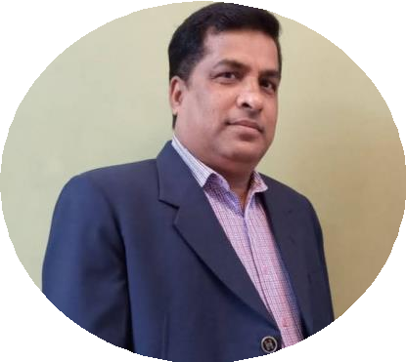

## Building+91 9733305556 HAIDERPARA, SILIGURI [MANIK.NJMF@GMAIL.COM](mailto:MANIK.NJMF@GMAIL.COM)

*A dynamic and seasoned professional with 25 years of experience in Sales and Marketing in the BFSI industry with a proven capability for revenue generation and profitability managing business volumes and growth, ability to manage diverse and large teams with expertise in developing and managing retail channels from scratch and an ability to build market share. A strategic thinker with a flair for charting out marketing strategies in new markets and to build market share in new areas of growth. A quick learner with an aptitude for problem solving, having an eye for detail and good interpersonal skills*

# CAREER SUMMARY

## BRANCH MANAGER AVIVA LIFE INSURANCE, SILIGURI

### Nov’22 – Present

* Managing the entire area of North Bengal, Sikkim
* Handle a team of Sales Managers.
* Responsible for the productivity of the sales manager, handhold the sales manager in the early stages
* Training and Product Support to Facilitate and anchor ongoing training and skills development for channels and employees including new hires at channels
* Manage financials of relationship, including support meeting of financial targets, sales promotion activities, support timely and correct commission reconciliation
* Ensure delivery of all mandatory training.

## BRANCH MANAGER TATA LIFE INSURANCE, COOCHBEHAR

### Aug’21 – Nov’22

* Managing the entire area of North Bengal, Sikkim and the lower part of Assam
* Help, Guide and support to the Business Associates Manager to Recruiting the team Agency Partners and building the agency
* Manage the relationship with the team, customers (internal & external)
* Responsible SAP/CAPs and Quality Advisors Recruitment (CAs)
* Managing sales and sales related activity on the channel.

## AREA MANAGER BHARTI AXA LIFE INSURANCE, SILIGURI

### Jun’19 – Aug’21

* Managing the entire area of North Bengal, Sikkim and the lower part of Assam
* Recruiting, training, and evaluating Relationship Managers and employees
* Ensuring compliance with the company’s policies and procedures
* Continuously monitoring and analyzing performance
* Assist Relationship Manager to recruitment (SAP/CAPs and Quality Advisors (CAs) and training
* Supervise a team of 6 direct reportees directly, & 150 sales personnel and indirect partners & advisors.
* Develop marketing plans to achieve sales target and increase brand visibility within the assigned area.

**ACHIEVEMENTS:**

* Have qualified for Various ZONAL and National contests
* Have achieved a budgeted target every year.

## MANAGING PARTNER (CHIEF MANAGER) KOTAK LIFE INSURANCE CO, SILIGURI.

### Nov’14 –June’19

* Responsible for Enrollment of SAP/CAPs and Quality Advisors Recruitment (CAs) &Training,
* Taking care of Urban areas and Semi Urban areas of North Bengal and Sikkim as a profit center.
* Supervise a team size of 5 SAPs, 17 CAs & 73 Advisors and 22 partners.

**ACHIEVEMENTS:**

* Produced 1 MDRT 1 CEO Circle and GOLD Silver club Members.
* Maintaining business hygiene 13th and 25th month persistency more than 87%

## BRANCH SALES MANAGER BHARTI AXA LIFE INSURANCE, MALDA

### Jun’06 – Oct’14

* Responsible for Sales Leaders and Quality Advisors Recruitment, Agents Training, Operations, through direct reportees. Managing the branch as a profit center.
* Motivate and handle a team of 12 Managers, 200 Plus agents to procure business and meet the branch budget
* Making Career Opportunity Presentations to recruitment prospects for the recruitment of advisors
* Making the hygienic aspects of the branch in compliance with the rules and regulations of the organization

**ACHIEVEMENTS:**

* Continuously Achieved more than assigned budget on main parameters
* Recognized for the Highest Agent Activation in the ZONE
* Awarded “Elite Club member” of the region for two consecutive years
* Received MD’s award for “Performer of the Year” in 2009.

## SR. MARKETING EXECUTIVE ORIENTAL BANK OF COMMERCE (FORMERLY GTB)

### Nov’98 – May’2006

* Joined as a Trainee and promoted up to the level of Sr. Marketing Executive and taking care of Corporate Deposit as well as Retails Liabilities and Assets.
* Key Accounts: ITC Salary Account, Apeejay group of Companies, Ispat Group, WBIIDC, WBIDC, Ganges Jute Mills, Graphite, Simplex Infra, Tantia Construction, IBP, J Thomas Etc.

# EDUCATIONAL QUALIFICATION

* Bachelor of Commerce

North Bengal University, 1992

* Date of Birth-3rd Dec’1972