CURRICULUM VITAE

AUROBINDA JENA

PH. No:+919090580317 (M)

E-mail:aurobinda.jena89@gmail.com

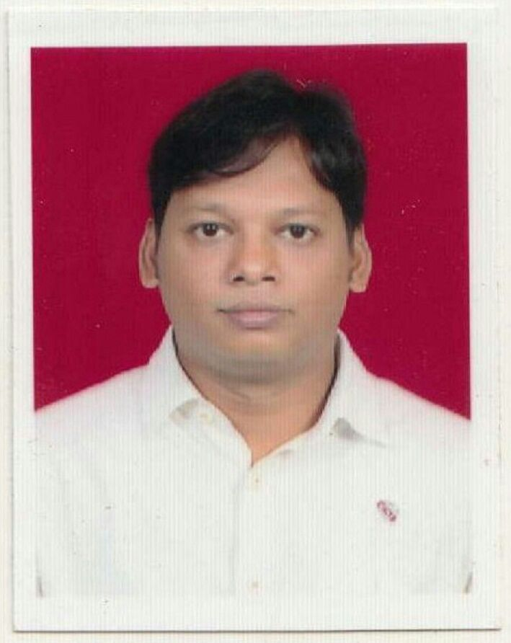

OBJECTIVE:

To work with a vision, determination and complete dedication, utilizing the potentialities gained so far on account of the educational knowledge and experience.

ACADEMIC QUALIFICATION

10th :- from B.S.E. in 2004
+2Arts :- from C.H.S.E in 2006
+3Arts :- from Utkal University 2012

TECHNICAL QUALIFICTION
Certificate in I.T.I.
Institution :- I.T.I , Chidananda I.T.C.
Duration :- 2 years
Trade :- Fitter
Year :- 2008

Certificate Course in Advance Machining
Institution :- C.T.T.C, Bhubaneswar
Duration :- 1 year
Year :- 2009

EXPERIENCE

- Sales Executive in Raj udyog , Cuttack Since May-2014 to December 2019
- Unit Manager – Busi.Dev. in ICICI Prudential Life Insurance Since jan 2020 to Jan 2022
- Agency Manager in Niva Bupa Health Insurance Since Feb 2022 to Feb 2023
- Working as Relationship Manager in Insurance dekho Since March 2023

HOBBIES:-

- Reading Books, listening Music
- Playing Cricket & Hockey

PERSONAL DETAILS

Name : Aurobinda Jena
Father’s name : Mr. Rajkishore Jena
Date of Birth : 01-01-1989
Sex : Male
Marital Status : married
Nationality : Indian
Cast : General
Contact no : +919090580317
Languages Known : Oriya,Hindi,English.
Permanent Address :
C/O : Rajkishore Jena
At : Odisha Council Of Sports,
Satyabratha Stadium
P.O : Buxi Bazar
Dist : Cuttack ( Orissa)
Pin no : 753001

Job location preference: Willing to be locate in odisha

Declaration:

I hereby declare that the information provided above is true to the best of my knowledge and belief.

Date :

Place : Cuttack AUROBINDA JENA

